Appendix A
GOT Images and Estimate
1)  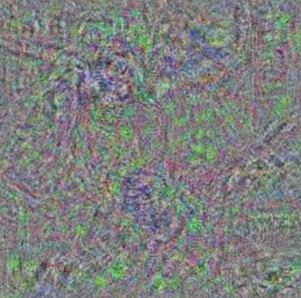  Was that a chimpanzee or a baseball player? | 2)  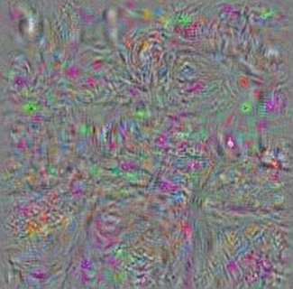  Was that a fire station or a confectionary?
3)  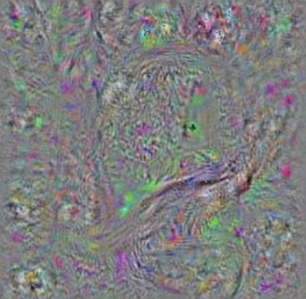  Was that an eel or a tiger shark? | 4)  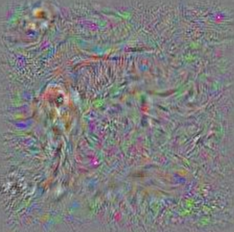  Was that a horse or a golden retriever?
5)  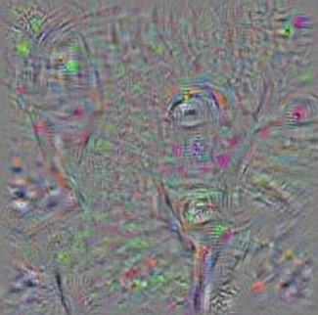  Was that a parking meter or a stop sign? | 6)    Was that a barn or a greenhouse?
7)    Was that an armadillo or a basketball? | 8)  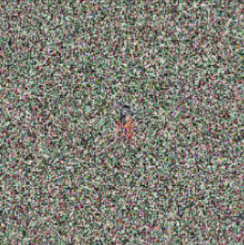  Was that an apple or a robin?
9)    Was that a mug or a bubble? | 10)  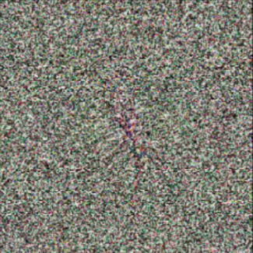  Was that a centipede or a crayon?

Estimated performance:
“Because there were only two options on each of the perceptual task questions, people who guessed randomly would have (on average) correctly answered the questions 5 times out of 10.

How many of the images do you believe you identified correctly beyond the chance level of 5, if any?

[Please enter a number from 0 to 5 to indicate how many of the images you think you got correct above chance.]

Appendix B
GOT Recommended Usage
The recommended version of the GOT can be accessed via the OSF link (https://osf.io/tkmua/) and by downloading the qsf file labelled “GOT”. This version uses both confidence ratings and an estimated performance score. When conducting analyses it is suggested to first z-score both the aggregated confidence ratings across trials and performance estimate and then use the mean of these values (i.e., mean of zConfidence rating and zEstimate).

